DAY-5

Document Version: 1.0

Date: 30/01/2026

DAY: FRIDAY

Prepared By: Testing & Documentation Team

UI COMPONENTS TEAM:

MODULE 5: TIME TRACKING

Introduction:
Time tracking in UI components involves measuring the time users spend interacting with different interface elements. It helps analyze user behavior, evaluate performance, and improve the overall user experience.
SCREENSHOT: PENDING
Description: PENDING

MODULE 6: COLLABRATION & COMMUNICATION

Introduction:
Collaboration and communication in UI components enable users to interact, share information, and work together within an application. These components support features such as messaging, notifications, shared views, and real-time updates, helping improve teamwork, coordination, and overall user engagement.
SCREENSHOT: PENDING
Description: PENDING

DASHBOARD DEVELOPMENT TEAM:

MODULE 2: PROJECT MANAGEMENT

Introduction:
Project management in dashboard development involves planning, organizing, and monitoring tasks to ensure the project is completed on time and meets requirements. The dashboard helps track progress, manage resources, and provide a clear overview of project activities.
SCREENSHOT: PENDING
Description: PENDING

MODULE 4: MILESTONE & PHASES

Introduction:
Milestones and phases in dashboard development represent key stages and important goals of the project. They help track progress, organize work, and ensure the project moves forward in a planned and structured manner.
SCREENSHOT:
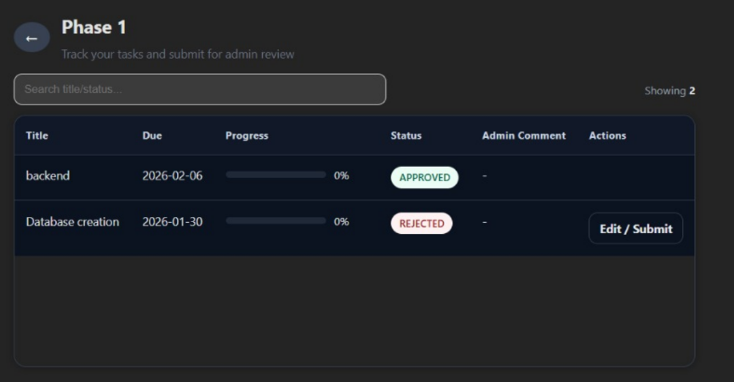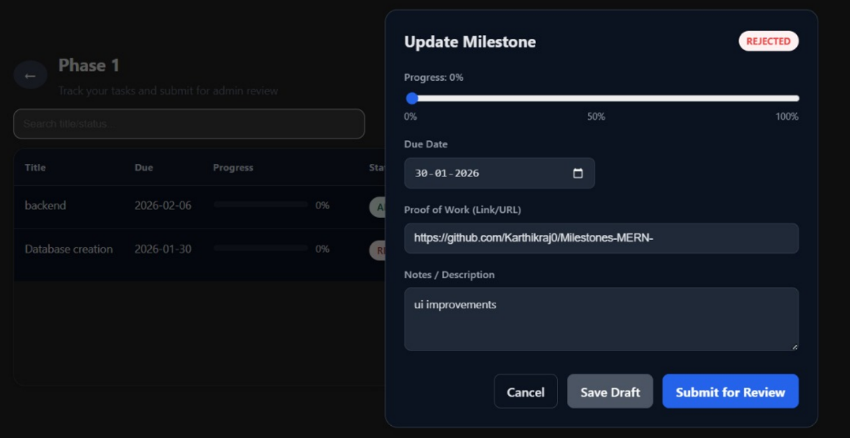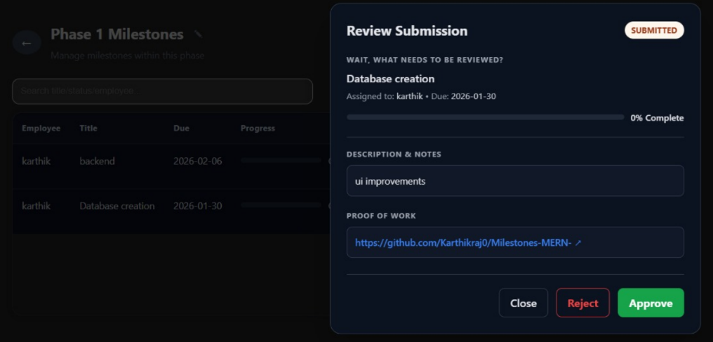
Description:
Milestone Phases & Review Flow
Phases were created to organize milestones in the dashboard.
Each phase can contain multiple milestones for better task management.
Employees can update their work and submit it for review.
Admins can review submissions and approve or reject the work.

TASK MANAGEMENT TEAM:

MODULE 7: ISSUE & BUG TRACKING:

Introduction:
Issue and bug tracking in task management involves identifying, recording, and resolving problems that occur during project execution. It helps teams monitor issues, assign responsibilities, and ensure timely fixes for smooth project progress.
SCREENSHOT: PENDING
Description: PENDING

MODULE 12: DASHBOARD VIEWS

Introduction:
Dashboard views in task management provide a clear and organized display of tasks, progress, and status updates. They help users quickly understand project information and manage work efficiently.
SCREENSHOT: 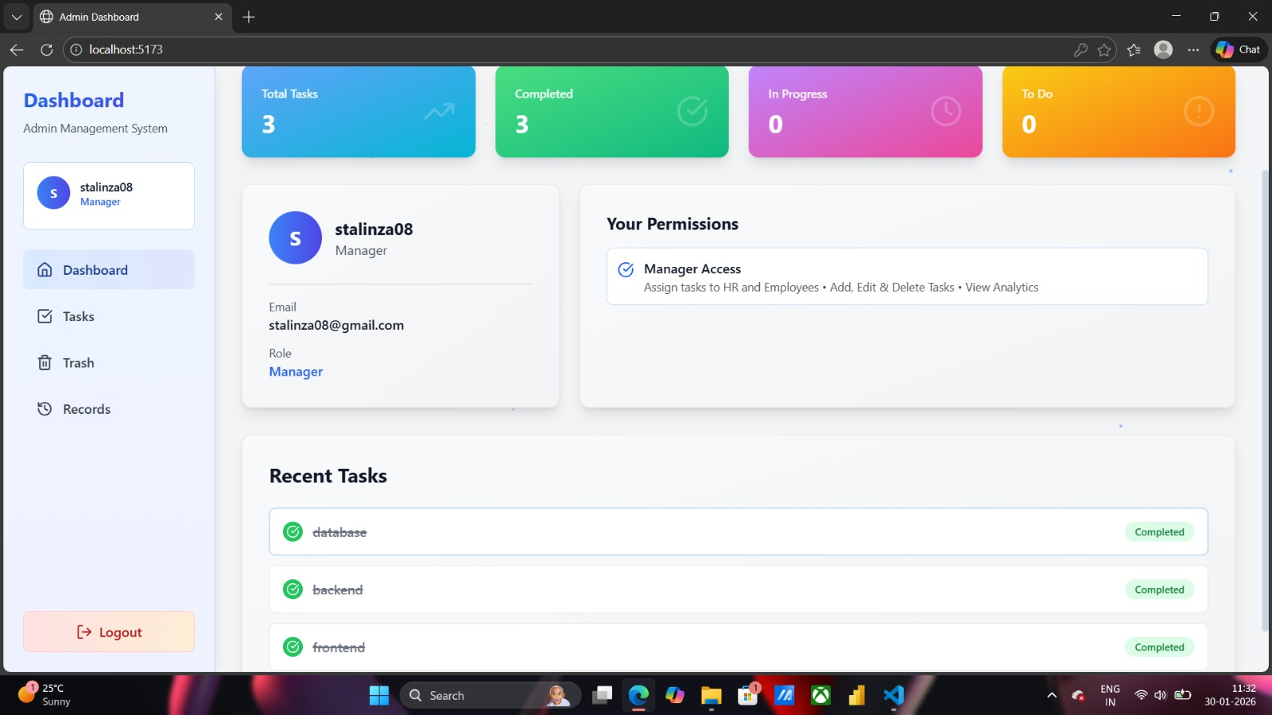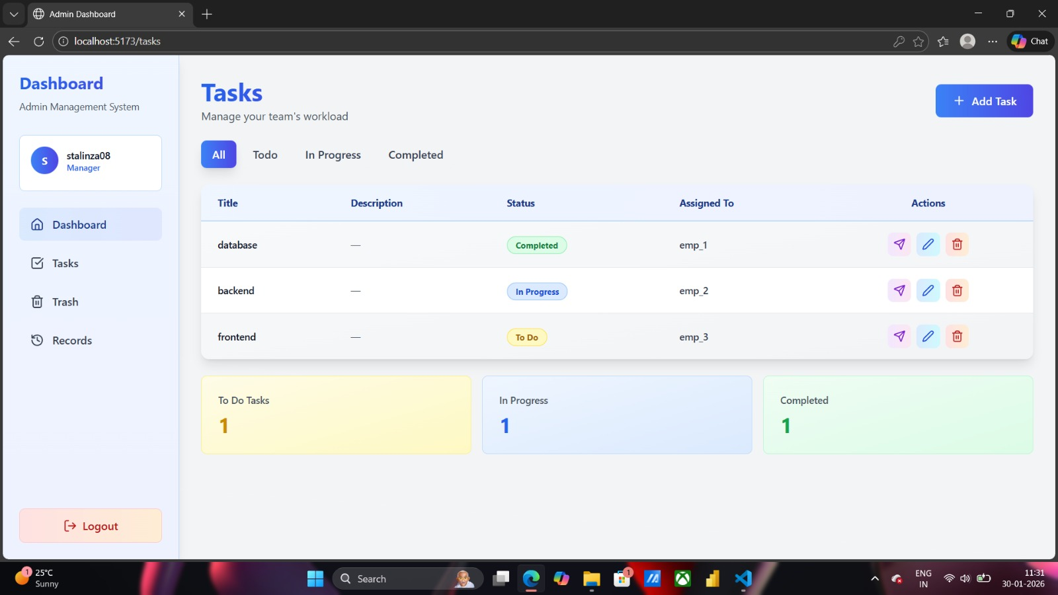
Description: Task Completion Verification
All assigned tasks were verified and confirmed as completed through the Task Management Dashboard

Features:
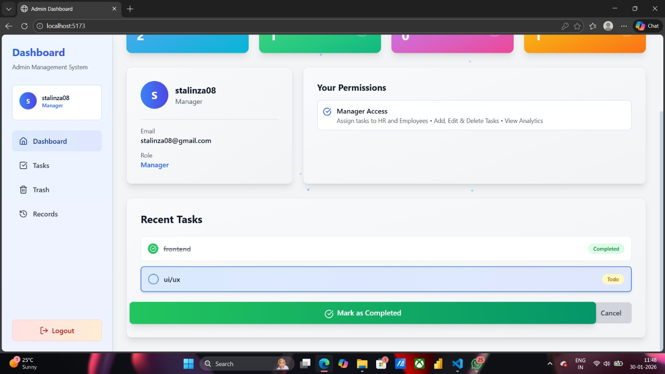
Recent tasks view:
This panel shows the tasks that created and their status (in-progress, todo and completed) and once the task is completed the task can be selected and marked as completed

ANALYTICS & REPORT TEAM:

MODULE 9: REPORT & ANALYTICS:

Introduction:
Reports and analytics provide meaningful insights by collecting and analyzing project data. They help track performance, identify trends, and support better decision-making through clear visual and statistical information.
SCREENSHOT: PENDING
Description: PENDING

MODULE 10: NOTIFICATION & ALERTS

Introduction:
Notifications and alerts in analytics and reports inform users about important updates, changes, or critical events. They help ensure timely awareness and quick action based on data insights.
SCREENSHOT: PENDING
Description: PENDING

DESIGN & UX TEAM:

MODULE 1: AUTHENTICATION & ORGANIZATION:

Introduction:
Authentication and organization setup in design and UX ensure secure access and proper user management within the application. They help users sign in safely, define roles, and organize teams for a smooth and consistent user experience.

SCREENSHOT: Completed on Day 4
Description: Completed on Day 4

MODULE 10: TASK MANAGEMENT

Introduction:
Task management in design and UX focuses on organizing, assigning, and tracking tasks in a user-friendly manner. It helps users plan work efficiently and ensures a smooth and intuitive experience.
SCREENSHOT: 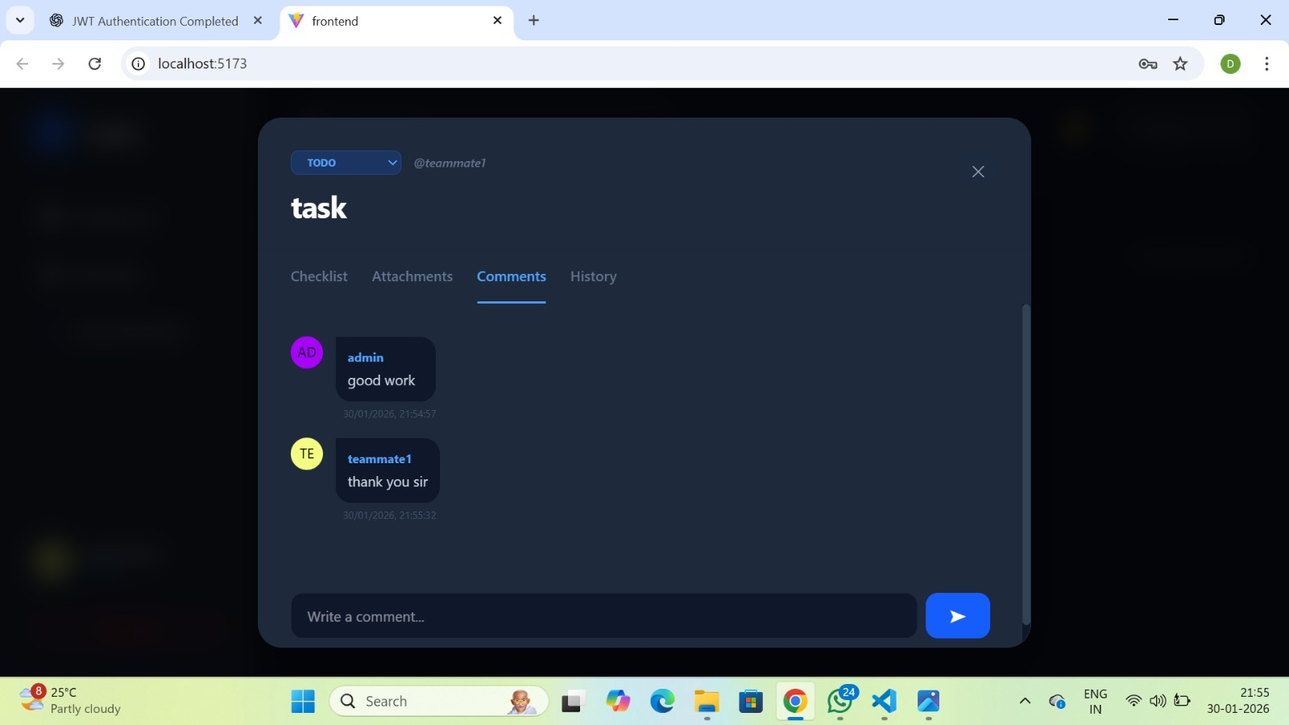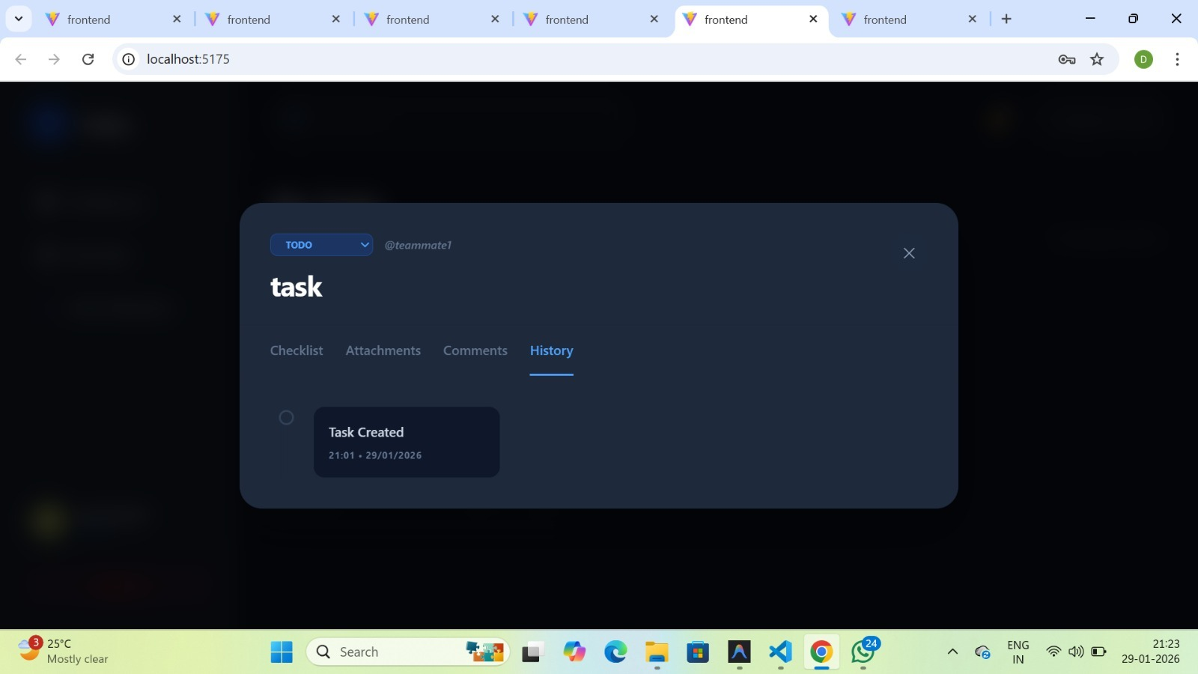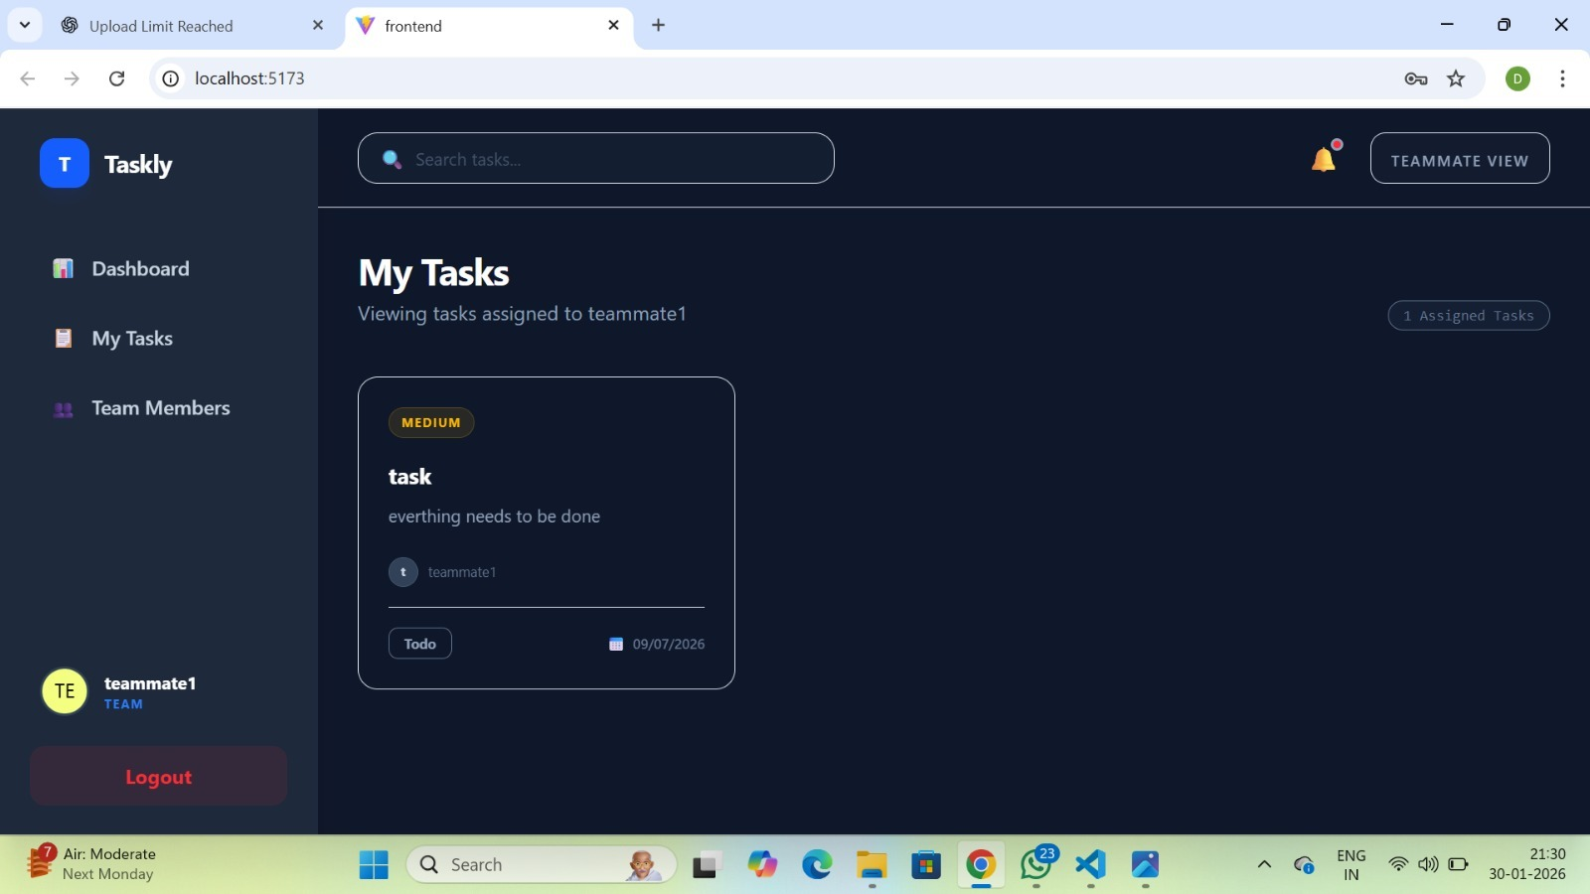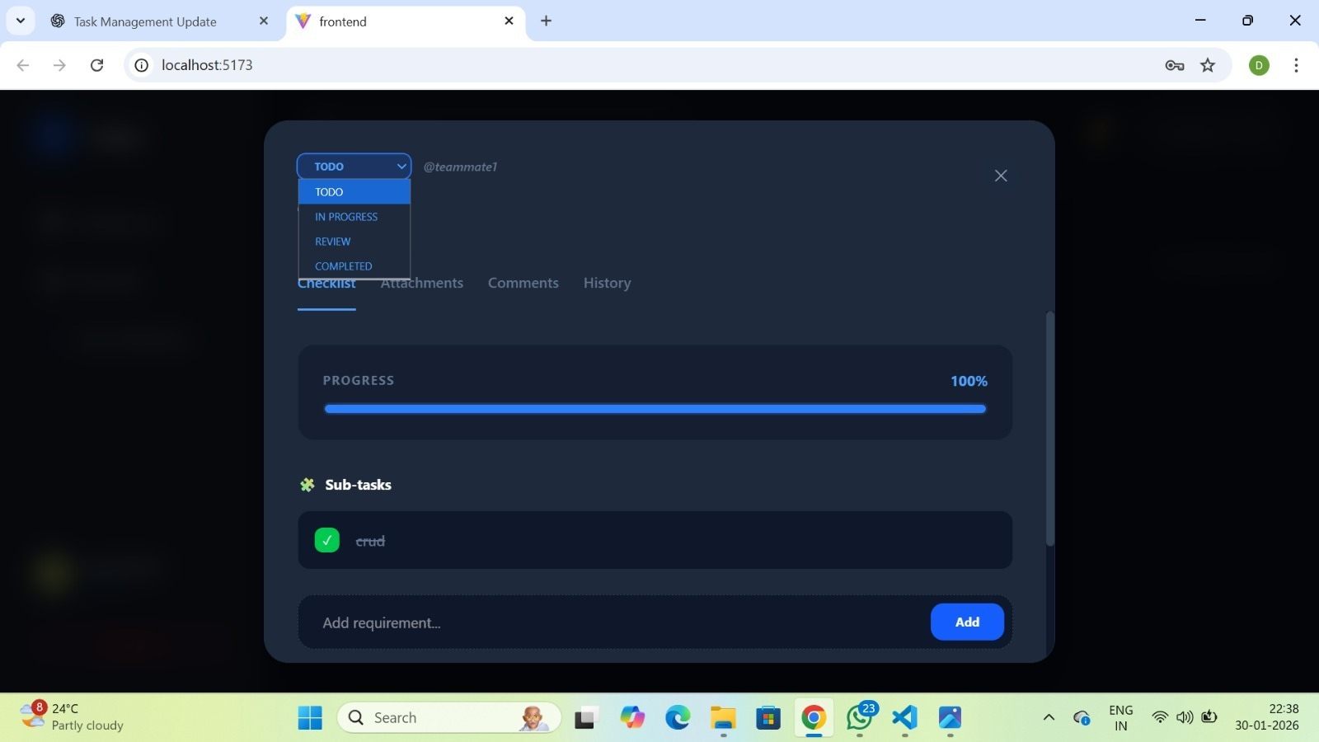
Description:
Added History and Comments sections in the task detail view. The history section tracks all task-related updates and activities. The comments feature allows both admin and teammates to communicate within each task. Teammates can view their assigned tasks in their dashboard, update the task status to In Progress, Completed, or Review, and also view the subtasks assigned to them.

